

**Singapore Institute of Management**

Diploma in Information Technology

Interaction Design

CA 3

April 2023 Semester

Team 3

|  |  |  |
| --- | --- | --- |
| **No.** | **Name** | **SIM Student No.** |
| L1. | Angeles Micah Josephine Flores | 10240945 |
| M2. | Sumcad Bryce Nicolas Fernandez | 10244185 |
| M3. | Ho Ka Yan Jeslyn | 10241485 |
| M4. | Eng Wei Quan Bill | 10243810 |

Table of Contents

Task 1 3

Solution 3

What is Digital Technology? 3

Major areas of Digital Technology 3

Selected area 3

Artificial intelligence 4

AI in Real-Life companies 4

Implication caused by AI 4

Selected Real-Life Company 4

Dominant areas of AI in Amazon: 4

Problems Spaces Affecting Operations/Human Factors 5

Alexa-Voice Assistant 6

Amazon Go 6

Amazon one 7

Task 2 7

Solution 7

Interaction Types 8

1. Point and Click Interaction 8

2. Form Fill in: 8

3. Question Answer/ Dialogue box: 8

Interface Types 9

1. Graphical user interface (GUI) 9

2. Form Base User interface 9

3. Voice User interface 9

Task 3 9

Solution 9

Proposed Lifecycle model: 9

Architecture diagram of Spiral Model 9

Reasons for Selection: 10

Advantages of Spiral Model: 10

Spiral Model of Proposed Solution: 10

Explanation: 11

Task 4 12

Solution 12

Low-fidelity Prototype 12

High-fidelity Prototype 15

Task 5 19

Solution 19

Selected Technique 19

Reason for selection 19

Detailed Plan of conduction 20

Data-Gathering Activity 20

Organized Actual Data 20

Experience on conducting the Survey: 21

Task 6 22

Solution 22

Qualitative Analysis 22

Quantitative Analysis 22

**Digital Technology**

# **Task 1**

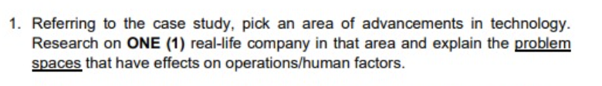

# **Solution**

## **What is Digital Technology?**

Digital technology is a term that is related to the use of electronic devices, resources, and tools to perform major operations like storing, transmitting, and processing information and data. Digital technology covers a wide range covering software innovations and computers, smartphones, and the internet. This technology has completely upgraded and changed the daily, real-life activities. Different industries including healthcare, education, banking, and entertainment have also been transformed. It makes it possible for people to interact with others around the world, obtain information instantaneously, and automate difficult jobs. The rapid increase in digital technology has also brought new challenges and problems for industry and real-life including privacy concerns, cybersecurity threats, the digital divide, etc. In general, digital technology has enormously changed the present era and will continue to do so.[1]

## **Major areas of Digital Technology**

Digital technology has widely revolutionized many industries. The major areas of technology will be discussed here:

* Artificial Intelligence is the trend of the era. Natural language processing, image recognition, decision-making, etc., are artificial intelligence subdomains. They have completely changed the business's and industries' conventional functionality.
* Robotics and the use of machines in manufacturing, healthcare, and transportation
* IoT relates to interconnected networks of vehicles, buildings, and physical devices.
* Blockchain constitutes of decentralized, distributed, and public ledger for secure and transparent transactions.
* Virtual Reality and Augmented Reality are technologies simulating the immersive virtual environment in the real world.
* Cloud computing accesses and stores data over the internet instead of on a local device.

## **Selected area**

The advancement of digital technology has greatly changed the world we live in today.   
Among all the different subdomains, the implications and advantages of **Artificial Intelligence (A.I.)** affect our daily lives in more ways than one.   
A.I. has revolutionized operations in many businesses and industries, it’s become an effective tool in completing repetitive tasks in an efficient manner, while aiding both the customer’s experience and the businesses productivity levels.

## **Artificial intelligence**

The creation of computer systems that can do activities that traditionally require human intelligence, such as speech recognition, decision-making, and natural language processing, is known as artificial intelligence (A.I.). AI is a swiftly developing area, with innovations and uses appearing frequently.

From healthcare and banking to transportation and manufacturing, artificial intelligence is applied in a wide range of sectors.

## **A.I. in Real-Life companies**

Companies all around the globe are universally adopting AI. One example being, in the sector of finance, A.I. is used today to detect fraud, assess risks, automate financial tasks, etc. For example, JPMorgan Chase has manufactured an AI-powered Virtual assistant to help their users with daily banking tasks. Similarly in manufacturing A.I. is brought into play to reduce waste and improve the control of quality. Tesla is using these A.I.-powered robots to assemble efficient and quality standard electric vehicles. In the healthcare sector, IBM, Watson Health, and Google Health are incorporating A.I. methods to bring about effective treatments, time-saving systems, and accurate diagnoses.

## **Implication caused by A.I.**

If A.I. has revolutionized industries with its ease, it has also deeply affected humans with its implications.

* Automation: The automation of tasks and processes has displaced numerous workers and has started replacing certain jobs that used to require a human’s expertise.
* Privacy: Algorithm processing with the involvement of A.I. requires the collection of tons of data from users. This has caused a concern among people about the privacy and security of their data.
* Loss of creativity: High dependency on A.I. and technology has seriously affected creativity among young minds.
* Discrimination: Due to the A.I.’s needs for data and training, poor training and feeding of false information can greatly influence the generated responses to be biased and discriminatory.

## **Selected Real-Life Company**

**Amazon** is the largest e-commerce platform that offers a variety of products and services for its customers under one roof. It was founded in 1994, starting its services from an online bookstore, which further got expanded to include a huge variety of goods and services like electronics, clothing, groceries, and streaming services. Amazon has also expanded into other areas, such as cloud computing with Amazon Web Services (AWS), and digital streaming with Amazon Prime Video and Amazon Music. Summing it up, Amazon has truly revolutionized our way of shopping, from offering a wide range of products to fast and reliable delivery, amazon has helped its users with easy and convenient online shopping.

## **Dominant areas of AI in Amazon:**

To create an effective place in the market and business, Amazon has effectively used artificial intelligence to automate its task and trend more towards technology. Some of the dominant areas in which Amazon has applied techniques and algorithms of AI include:

**Recommendation Engine:**

Amazon's recommendation engine is powered by machine learning algorithms that analyze user data to suggest products that match their interests and needs. Past purchase history, behaviors of browsing, and many other factors are considered and analyzed to make personalized recommendations for each user.

**Alexa-Voice Assistant:**

Alexa is a popular AI-powered digital assistant that is integrated into Amazon devices like smart speakers and other devices that enable users to interact with the help of voice commands.

**Amazon Go:**

The first cashier-less convenience store is introduced and operated by Amazon. They make use of computer vision, and deep learning algorithms through a sensor fusion to pick up items and walk out of the store without going through any traditional checkout process.

**Amazon one:**

This contactless biometric authentication system allows users to pay for their groceries and bills using the print of their palms. The system uses computer vision and machine learning algorithms to recognize the print of the palm and associate that is connected to the user's credit card.

## **Problems Spaces Affecting Operations/Human Factors**

**Recommendation Engine**

Following are the problems that are faced by users due to the A.I.-based recommendation engine proposed by Amazon.

1. **Biased Recommendations:**

The recommendation engine uses machine learning algorithms to recommend products to users based on their history or clicks. However, if the algorithm is biased, it may recommend products or categories that are not related to a particular user. Incorrect recommendations coming in Amazon web or mobile are sometimes also due to biased algorithms. When people with similar backgrounds and experiences work together to create algorithms, it may result in biasness which in turn recommends wrong products to users. This problem in turns destroys the trust and confidence of users in the recommendation engine.

1. **Overfitting:**

This problem occurs when the engine is trained and tested on a very limited dataset. This problem of overfitting results in recommendations that are usually too narrow or very specific. Overfitting and incorrect recommendations pave a path for poor user experience where customers feel that the recommendations are not related to their interests or needs, removing their focus on the actual products.

1. **Setting up the A.I. Department:**

With the increasing use of artificial intelligence in Amazon e-commerce stores, owners face an increased need to set up an AI department. The required skillset to efficiently implement A.I.-based systems is still rare in the market. Finding the perfect people, installing machines, training, etc. of employees to help them reach the required efficiency needed for the AI technology stack is still a problem for owners and shareholders.

### **Alexa-Voice Assistant**

**Misinterpretation:**

Amazon undoubtedly holds a very large customer base. People from all over the world, have different languages and dialects. If a customer chats with Alexa in such a dialect that is unidentified by Alexa, it can implement misinterpreted commands. This issue might lead to poor user experience where users are frustrated by incorrect answers and commands.

**Privacy issues:**

Data security and privacy is other concerns Amazon is dealing with about AI. With Alexa, there is a risk of sharing sensitive user information in the form of accidental or intentional recording. This may cause legal or regulatory problems as well as harm users' confidence in the Alexa-Voice Assistant.

**Issue of accuracy:**

Another important issue faced by users of Amazon voice assistants is the problem of the accuracy of commands after listening to the voice. It is a common use case where the command given by customers to Alexa is understood correctly by her, but the response generated is late or incorrect. It is due to the limited data set on which it is trained. Incorrect responses generate frustration in the users reducing their interest in the system.[2]

**Low awareness:**

Despite all the privacy and accuracy issues, Alexa is still one of the remarkable AI features implemented by Amazon. However, many users and customers are still unaware of its use and ease in their daily life. They have a lack of trust in technology and have restricted themselves. This problem should be addressed so that all customers can make use of AI-powered voice assistant.

### **Amazon Go**

**Job Replacement:**

Amazon Go is a total cashier-less experience, where users just scan their phone upon entry, shop for products and goods, and leaves the shop with a scan. There are no cashiers or store workers in Amazon Go. This approach has severely affected the Jobs of people. As there is no need for workers now because the same tasks are done efficiently by machines. This in turn leads to job layoffs creating disappointment and risk among employees.[3]

**Incorrect charging for similar products:**

As the shops are fully equipped with cameras and sensors, which detect which person has selected and placed the product in her/his cart. However, the system is still unable to effectively differentiate between products of almost the same appearance but different pricing. This in turn leads to incorrect bill productions and checkouts for users. Similarly, if a user place back the product but in the wrong aisle, the system still generates the wrong result as that product might be charged according to the price and weighted products of that aisle.

**One Shopping Cart for the whole family:**

If a family enters with more than 1 family member, they should be charged on one account, rather than each person charged separately on their accounts. The family contains many members such as very old ages persons or small kids, who still don’t have any debit card and cannot register themselves on the app. If they pick a product system and place it in the cart of another, the system cannot generate an accurate bill which might result in a loss on expenses. [4]

**Exposure to theft:**

If the system is inaccurate or slow, resulting in inaccurate checkout generation, even the most trusted citizens find it a no big deal of theft or inaccuracy. As this condition is more linked to “an error caused by the system that is not in their control”. In this condition, Amazon experiences huge losses if the system is down or tackled with an error.

### **Amazon one**

**Privacy Concerns:**

Given that biometric information like palm prints is collected and stored by Amazon Go on the checkout of customers, one of the AI-related issues faced by Amazon One is the potential for security and privacy risks. People find it unethical and illegal that their biometric data should be stored for a long enough time. This could result in backlash and a poor public image resulting in negative public perception.

**Incorrect authentication:**

There is a need for an efficient and seamless system because in a case where a palm is incorrectly identified and linked to another person's account or credit card resulting in charging the customer for the goods which have not been purchased by the user. The system must be able to accurately and quickly authenticate users, while also providing a smooth and intuitive interface.

# **Task** **2**

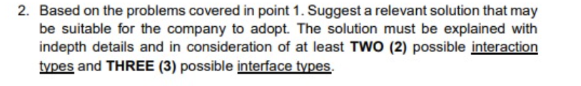

# **Solution**

Keeping in view the above problems related to artificial intelligence, the solution lies in making effective changes and modifications to existing systems. New modules should be implemented in the Amazon system. As one cannot completely ignore or overrule artificial intelligence, the solution to the problems related to it exists in adding and modifying its modules rather than omitting its existence. A unified solution will be created that will integrate many interaction types and possible interface types. This solution will then be implemented. The concerned solution lies in creating the following changes and additions in those interfaces and algorithms where an implication is prevalent.

## **Interaction Types**

### **Point and Click Interaction[5]**

**Incorrect Recommendations**

In case when a product is mistakenly added to the cart by the customer and he does not check it out, the recommendation engine is activated producing similar products for the user related to that unneeded product. To solve this recurring problem, there should be a feedback button feature added to the account of the user to provide input on the relevance of recommendations. This will enable users to customize their recommendations by indicating which products they are interested in, or by providing feedback on the relevance of the recommendations they receive.

The interaction which is involved in the solution of this problem is click interaction. In these interactions, users click on buttons or links to trigger an action or navigate to a new page. In this case, the customer will click the button of the feedback form on the top of the page to get directed to a page where a form appears that will modify the recommendations given to the user.

**Displacement of Jobs due to Amazon Go:**

Privacy and threat issues in Amazon One and Go can be tackled by implementing strong data security measures and encryption protocols to protect the biometric data collected by the system Additionally, Amazon should state its data policies and provide clear information to customers about how their data is being used and stored. This will ensure that the system will only retrieve data from registered customers who agree with Amazon’s data policies.

**Low awareness about the use of Alexa:**

Many customers are unaware of the advantages of using Alexa in their e-commerce experience. There should be a visual interface depicting demos about how to use Alexa.

There should be an interface assessable through a click, that will contain demos and videos about the use of Alexa. Voice interaction will be used by customers in these videos. This system should also be able to listen to and answer the queries of customers.

### **Form Fill-in:**

Form fill-in user interaction can also be used in case of displacement of Jobs and awareness about Alexa use. Users will be redirected to a form that will be filled to apply for technology training program and guidance program about the use of Alexa.[6]

### **Question Answer/ Dialogue box:**

**Biased Results by Recommendation System:**

To solve the problem related to the biased result produced by the recommendation system,

“An explainable AI” technique should be implemented. This feature should be designated to explain **why** a particular product has been predicted by the system. This would help to build trust and confidence in the recommendation engine.

This interaction type can be used to implement this feature. In question answer or Dialogue boxes, windows popup showing additional information to a user. In this use case interactions can be used to reveal more information about a recommended product answering the questions like

* Why the product has been recommended?
* How it has been related to the interests of the user?

## **Interface Types**

### **Graphical user interface (GUI)**

It will be used to implement features constituting visual appeals, additional messages, and hovers over the products. It will be used to solve the problem of explainable AI.

The GUI could provide users with a visual representation of the authentication process and any associated information, enhancing the user experience and improving efficiency of Amazon One and Amazon Go.

### **Form Base User interface**

The interface implemented in technology training to solve the issue of Jo replacement and to get the guidance related to Alexa- AI powered voice Assistant will be formed based on the first step when the user will submit a form to request training. Upon approval, he should be directed to a chatbot interface where ml algorithms can be applied to guide and teach the humans.

### **Voice User interface**

The voice user interface could provide a guiding experience to users. This interface will be used in interface containing demo videos of Alexa. This screen will be accessed after filling a form by the user. We can also implement a chatbot here that will interact with users based upon its voice to answer their queries and guide them about the appropriate use. It will maximize the advantages that will be gained through Ai assistant in the field of ecommerce.

[7]

# **Task 3**

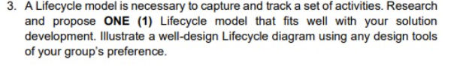

# **Solution**

## **Proposed Lifecycle model:**

To generate a system that will solve all the above problems, spiral model will be considered in this case.

## **Architecture diagram of Spiral Model**

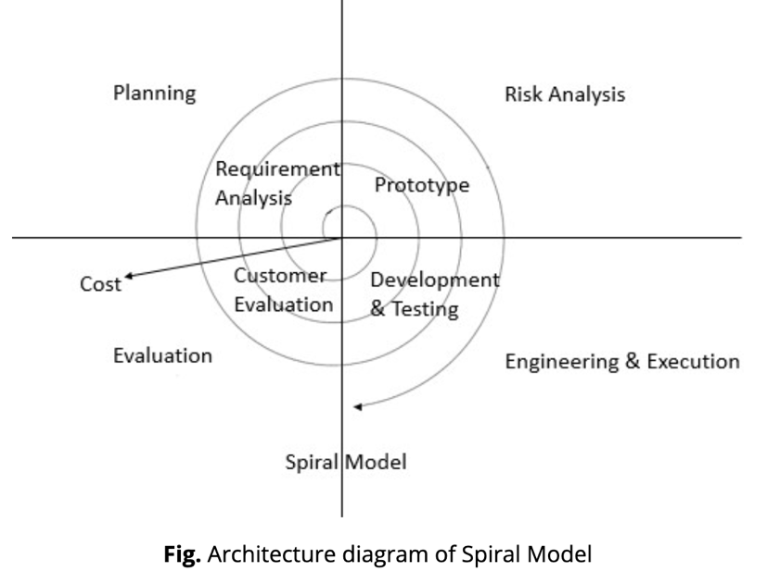

[8]

## **Reasons for Selection:**

The proposed life cycle model is called the Spiral Model. It is a risk-driven model that emphasizes continual feedback and iteration, it is most suitable for projects where requirements and specifications may change over time.

Since the proposed solution involves improving user experience, efficiency, and speed, so spiral model can be considered as a good fit. Continual updates to the specifications or details about the both the buttons and forms can be put into effect as The Spiral Model is iterative. This means that developers can address and minimize risks at various points of the creation process.

## **Advantages of Spiral Model:**

* Efficient estimation of costs
* Allows risk analysis and risk handling after every cycle
* Flexibility which allows designers to accurately make adjustments at later phases
* Suitable for developing a product that is tailored to fit the user’s requirements
* Preferred for complex, large-scale, and risky projects

## **Spiral Model of Proposed Solution:**

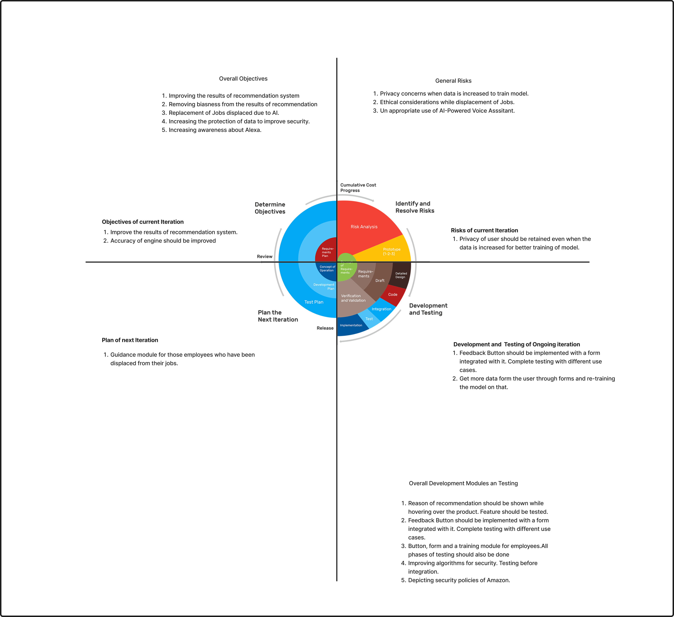

[9] Image edited in Figma.

## **Explanation:**

The life cycle model is used for the solution of problems in the spiral model. In the spiral model, interactive approach is combined with the waterfall model. As this project is large so this concerned model has been chosen. There are general objectives, risks, and development tasks related to the solution. They require to apply an incremental approach and build the final product by integrating modules one by one. However, in combined solution an iterative approach can also be applied because the same phases will be covered and implemented in the next iteration. For example, the general objectives for the system are:

* Improving the results of the recommendation system
* Removing biases from the results of the recommendation
* Replacement of Jobs displaced due to AI.
* Increasing the protection of data to improve security.
* Increasing awareness about Alexa.

Designers will decide about the tasks which should be covered in the next iteration, e.g., they start with improving the recommendation engine. The risk factors which are involved in this iteration are privacy concerns and they need to be tackled in this complete cycle. In the development and testing module, we will generate a button which leads to a pop-up form. This form will ask users questions based on the current recommendations and how the system could be improved. The purpose of this is to create a better experience for the user by improving the prediction algorithm. The next step after development would be to test the prototype and gather feedback on it. Then at the end of a cycle, the team will reevaluate and discuss which task to take on in the following cycle. This sequence of steps will repeat until all the objectives are achieved.

# **Task 4**



# **Solution**

## **Low-fidelity Prototype**

High-level design concepts are translated into tangible and testable artifacts. The following prototype or wireframe has been designed to solve the problems that were discussed above due to AI. Images are attached here as a reference.[10]

It is to be mentioned that all low fidelity prototypes listed here have been designed in Figma designing software.

**Main screen:**

The problem of bias and incorrect recommendation is solved by introducing a feedback button on the top of navbar, which then links to a form. This will notify the system about the unfitting recommendation and prompt the A.I. to learn how to improve the recommendation list of the user. Moreover, a message will hover over the recommended product indicating that the user searched for a similar product.

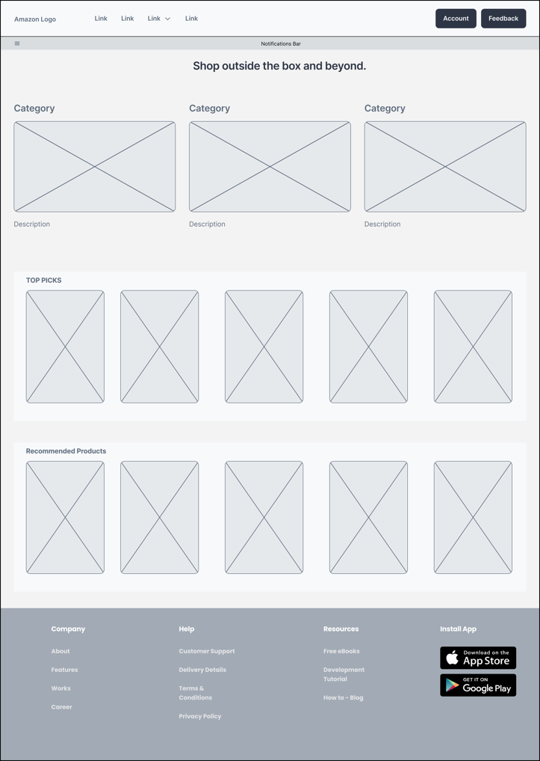



**Form to improve the recommendation:**

The button on the top right corner is linked to a feedback form. The customer will then input the appropriate information about the concerned product, which the system will then send this information to backend in order to retrain the algorithms about the personalized recommendations.

**Side navigation bar:**

A navigation bar will be accessed by them clicking on three lines button. This side navigation bar will have two separate buttons of “**Tech Training**” and “**Alexa Demos**” which are designed to solve the problems of Jobs Displacement and low awareness about advantages and uses of Alexa-AI powered Virtual Assistant.

**Alexa Demos:**

Low fidelity prototype for the demos and vides related to Alexa, its coaching and uses is given below**:**

**Technology Training**:

In order to solve the problem of job displacement, employees of Amazon must be given training and coaching about the dominant jobs of coming area. This will allow employees to think about their future and strive to be open to upskilling in order to stay relevant in the market. With this in mind, to help employees, an online learning platform should be designed which will enable the employees to upskill themselves. The designed form below, include chatbots and A.I. powered assistants that will teach employees who have some technological knowledge and are willing to upskill.

## **High-fidelity Prototype[11]**

It is to be mentioned that all high-fidelity prototypes listed here have been designed in Figma designing software.

**Main screen:**

The solution of above problems has been designed and mentioned below:

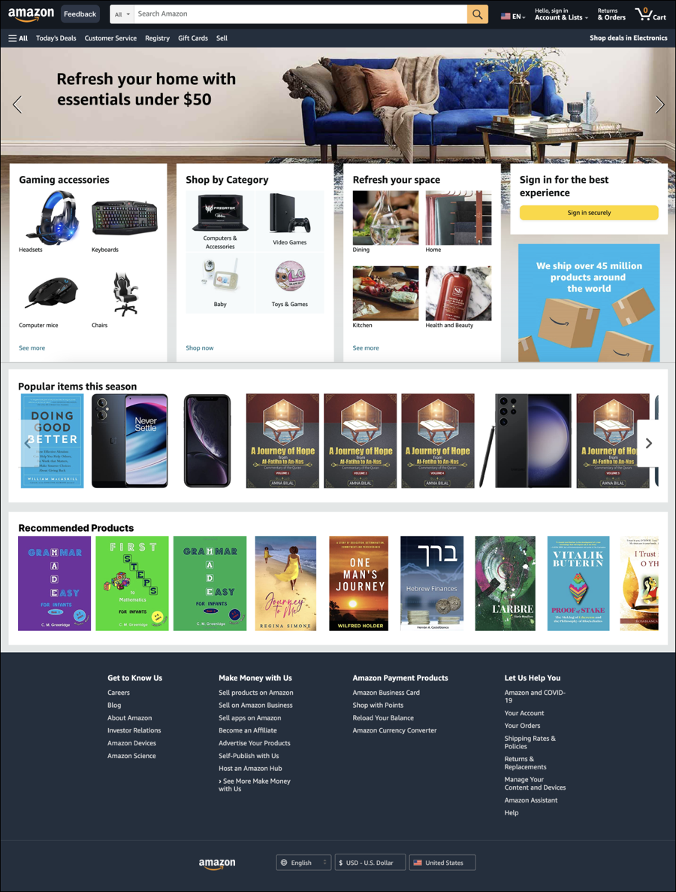

Upon hovering over the individual recommended products, a message will appear at the end of the product depicting the reason as to why it was recommended.

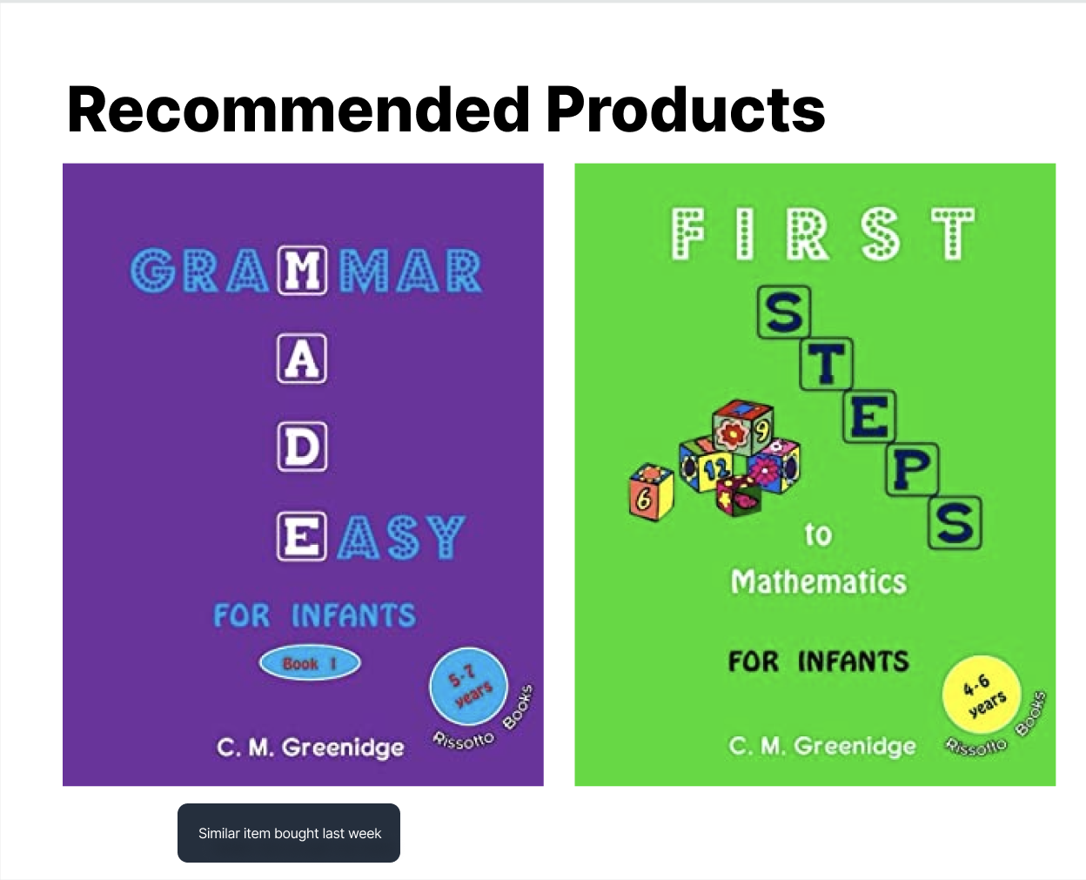

**Form to improve the recommendation:**

A detailed design of the form containing the recommendation improvements.

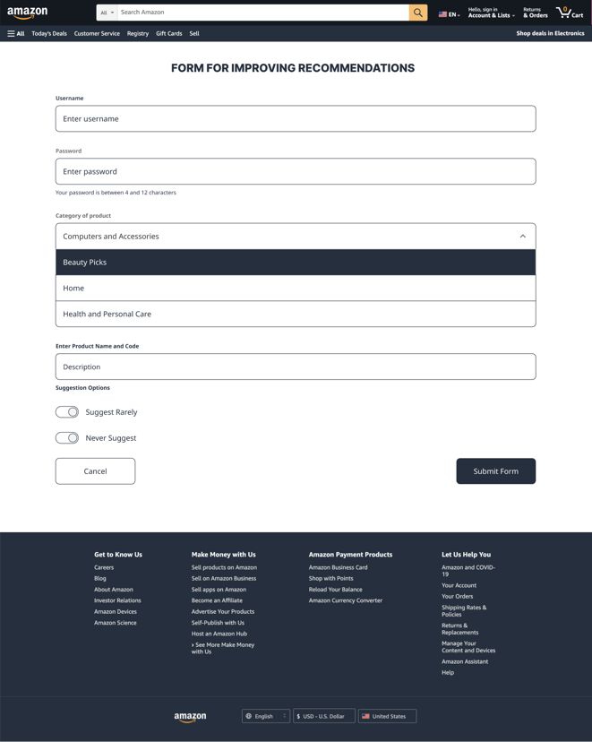

**Side navigation bar:**

All internal details of side navigation bar are displayed below.

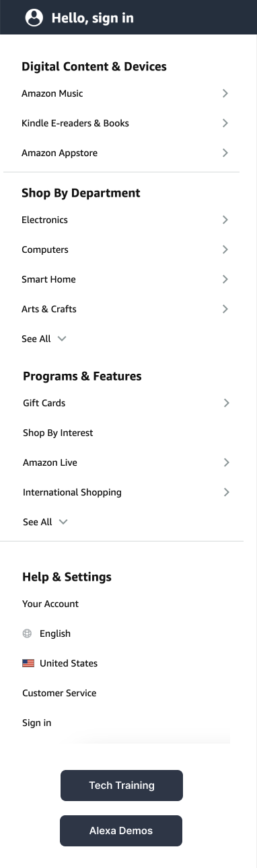

**Alexa Demos:**

This isthe screen displaying videos about the training of Alexa.

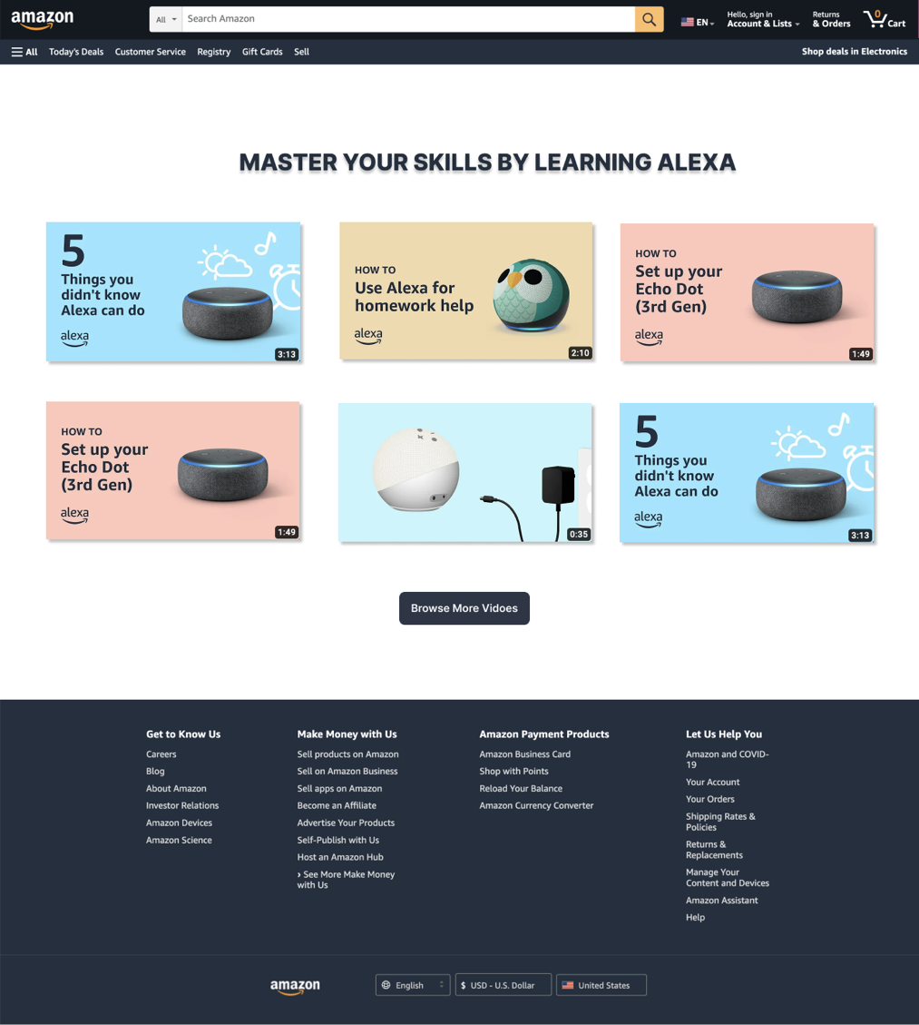

**Technology Training**:

In order to solve the problem of job displacement, employees of Amazon must be given training and coaching about the dominant jobs of coming area. This will allow employees to think about their future and strive to be open to upskilling in order to stay relevant in the market. With this in mind, to help employees, an online learning platform should be designed which will enable the employees to upskill themselves. The designed form below, include chatbots and A.I. powered assistants that will teach employees who have some technological knowledge and are willing to upskill.

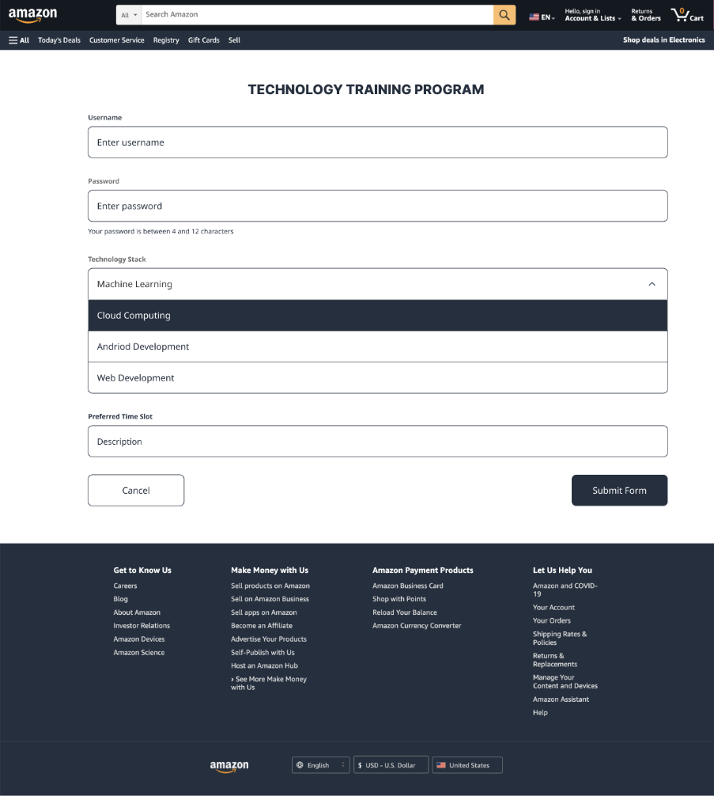

# **Task 5**

# **Solution**

## **Selected Technique**

There are countless data-gathering techniques to use in user experience research, when generating real-time data and performing activities related to that data. Out of all the options, **Questionnaires** and the use of detailed surveys would be most suitable in gathering efficient data at the same time training our models to that data.[12]

## **Reason for selection**

With UX surveys and questionnaires, researchers can quickly gather huge amounts of data rather than performing one by one interviews. These interviews are also an effective data-gathering technique, but they need time to complete their proceedings. **Surveys and Questionnaires** can assist with both open and closed questions. **Closed questions** are those which have only one-word answer however those questions which are descriptive, and explanation based are termed **open questions**. Open and closed questions in Surveys and Questionnaires are carefully picked to obtain information and data that can be used to process and compare data to draw meaningful conclusions.

## **Detailed Plan of conduction**

Following is the plan for the conduction of Surveys:

1. **Defining the objectives of survey**

The first step should be stating the main goal and objectives of surveys and questionnaires. In this case, the main goals are to gather more information about the preferences of customers, their notion about the biasness in recommendation engine predictions, and their thoughts on replacements of Jobs due to AI.

1. **Designing the questionnaire**

The questionnaire should be designed in such a way that all questions related to the objectives and goals of survey should be included in it. They will provide actionable insights for improving the recommendation system. The questionnaire should always be easy to understand and should not be very long.

1. **Identifying the target audience**

The target audience should be identified based on the objective of the survey. In this case, the target audience would be Amazon users and customers who have used the recommendation engine.

1. **Conducting the survey**

There are various platforms to survey using social media, email, using the Amazon website. Customers or users who are involved in that survey should be informed about the objectives. They should also be assured about their privacy and confidentiality of responses to surveys.

1. **Analyzing the data**

The data gathered through the survey should be analyzed to identify trends and patterns. The focus should be on the parameters that will improve the recommendation engine and ML algorithms such as age group, field, product interests, number of items purchased, frequency of purchase, etc.

## **Data-Gathering Activity**

Data gathering activity of taking surveys can be held through the website of Amazon. Furthermore, visiting the areas that have a greater number of Amazon customers and conducting live surveys can also help in gathering data. Amazon Go stores can also be visited for questionnaires.

## **Organized Actual Data**

A small sample of actual data gathered through these activities is given below:

| **Customer ID** | **Age Group** | **Field** | **Product Interests** | **Number of Items Purchased** | **Frequency of Purchase** | **Frequency of Searching** | **Ratings** | **Feedback on Recommendations** |
| --- | --- | --- | --- | --- | --- | --- | --- | --- |
| 001 | 45-54 | Sales | Groceries, Home Decor | 10 | Weekly | Daily | 4.5/5 | Recommended items were useful |
| 002 | 35-44 | Healthcare | Fashion, Home decor | 10 | Monthly | Weekly | 4/5 | Recommended items were relevant |
| 003 | 45-54 | Finance | Groceries, Appliances | 8 | Monthly | Daily | 3.5/5 | Recommended items were not useful |
| 004 | 18-24 | Computer Science | Gaming, Sports | 12 | Weekly | Daily | 4/5 | Recommended items were helpful |
| 005 | 25-34 | Education | Books, Stationery | 5 | Monthly | Weekly | 3/5 | Recommended items were not relevant |
| 006 | 55-64 | Law | Travel, Home Improvement | 20 | Weekly | Daily | 5/5 | Recommended items were very useful |
| 007 | 35-44 | IT | Electronics, Gaming | 12 | Monthly | Weekly | 4/5 | Recommended items were helpful |
| 008 | 25-34 | Hospitality | Beauty, Health | 3 | Weekly | Daily | 3.5/5 | Recommended items were somewhat useful |
| 009 | 18-24 | Media | Fashion, Accessories | 6 | Monthly | Weekly | 4/5 | Recommended items were relevant |
| 010 | 25-34 | Marketing | Electronics, Books | 15 | Weekly | Daily | 4.5/5 | Recommended items were useful |

## **Experience on conducting the Survey:**

Surveys are also linked with may good and bad experience. There are many challenges that are faced by people taking the survey to gather more data. Conducting live surveys boost confidence and interaction with the end user, however low response rates, inaccurate responses, incomplete or partial completion of forms all are the difficulties that are encountered with the survey. It is also important to ensure that the survey is distributed to a diverse group of users to reduce biasness in the data.

# **Task 6**

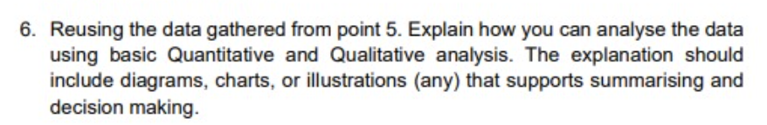

# **Solution**

## **Qualitative Analysis**

**Grounded Theory:**

Developing a theory or explanation based upon data collected from surveys questionnaire instead of a starting with a pre-existing theory based upon previous data is called as grounded theory. This theory can be effectively used to draw new insights from data and understanding from the data.

**Content Analysis:**

In this analysis open ended questions containing explanatory answers are used to for categorizing and analyzing of responses. Surveyors can find out by analyzation that people form which age group people and profession, are interested in products and goods.

**Case studies:**

This involves analyzing a specific individual or group in-depth, and can provide rich insights into their experiences and perspectives.

A case study can be defined as **an intensive study related to a person, a group of people or a unit, which is aimed to generalize over many sectors and units[13].** A case study is an analysis technique that dives deep into examining an individual or group of people and their experiences and perspectives. This technique is used to gather data from the relationship between people buying products, their frequency of buying, and the number of items purchased.

**Thematic Analysis**:

Thematic analysis, which is in close comparison to content analysis, covers finding patterns in the data. This analysis is more concerned with the underlying meaning and interpretations of the responses.[14]

## **Quantitative Analysis**

## 

**General techniques:**

Quantitative analysis is the usage of numerical methods to determine the scale, quantity, or the overall scope. There are two general techniques when it comes to quantitative analysis. Firstly, there is averages, which include calculating the mean, median, and mode values, with the purpose of summarizing and identifying the trends in collected data. The mean is the average of all numbers, it relates to the central value of the data collected. Similarly, the median also determines the central tendency of the given data set. Lastly, mode is the most frequent value or most frequent product that is in demand. The second quantitative technique is to use percentages. This technique is used to standardize data and compare multiple sets of responses.

**Histogram Creation:**

Visualization of data is an important aspect to study, read and categorize data. Histogram can be used to give researchers the idea about most hit and popular products among different age groups so that this data can be effectively used to tailor end users’ recommendations accordingly. A graph can be used to depict a relation between age groups and frequency of products ordered according to age group can be constructed by learning form a similar graph pasted below.

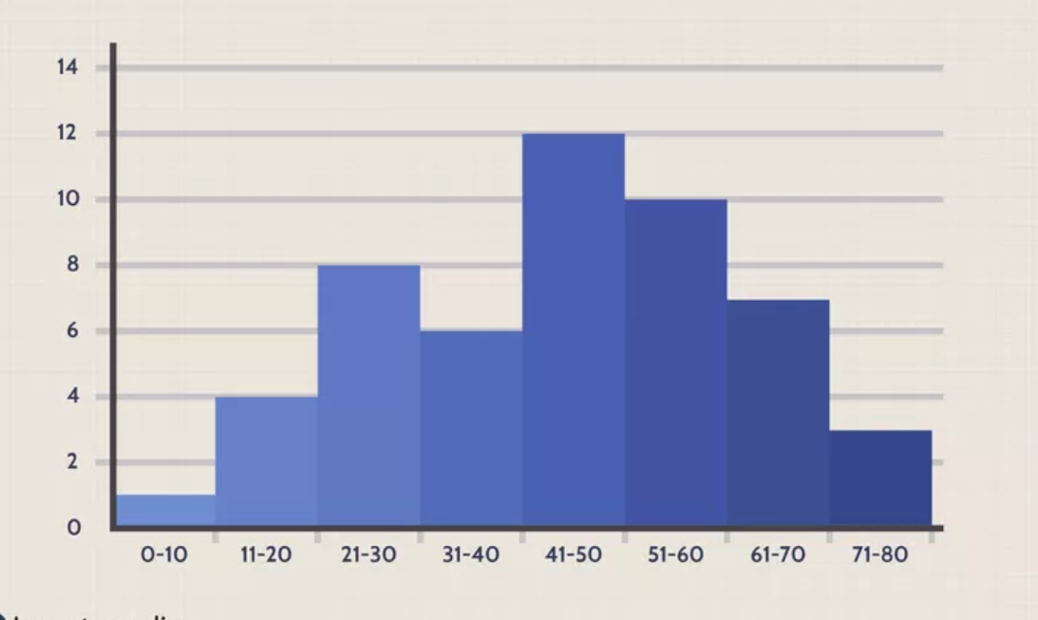

**[15]**

**Scatterplots:**

Scatter plot is an effective way to study about the dispersion or aggregation of data. They show the extent of coorelation between observed quantities or phenomena. If there is no association between the variables, the points on the coordinate plane appear to be randomly dispersed. Scatter plot can be used to depict the relationship between different variables like frequency of purchases related to targetted age groups. A general scatter plot has been mentioned here to learn more about this type of quantitative anlysis.

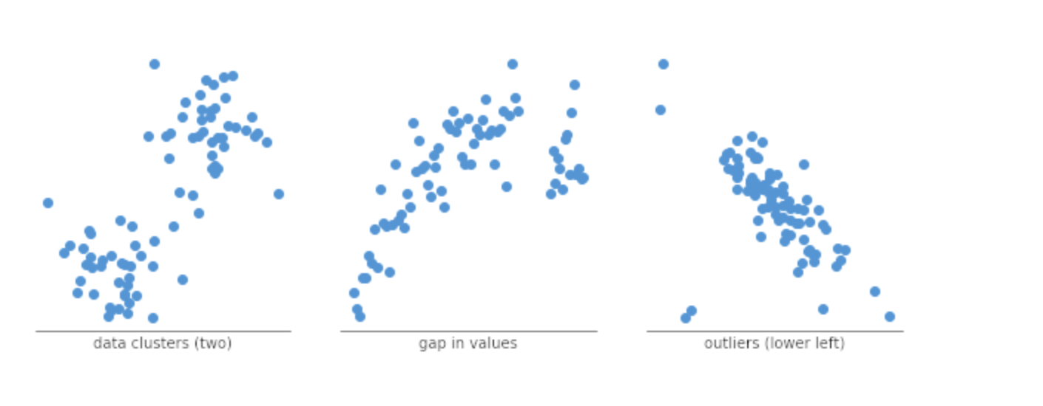

**[16]**

**Box plots:**

Similarly, another data visualization and analysis technique is formulation of box plot. It depicts the median, upper and lower quartiles, minimum and maximum values, and any outliers in the dataset. It is very effective and easy to read, as **it can summarize data from multiple sources and display the results in a single graph**. Surveyors can also use box plot in this case study for establishing a quantitative relationship and conducting an analysis about the researched material. A general box plot is referred here to give an idea bout box plot.

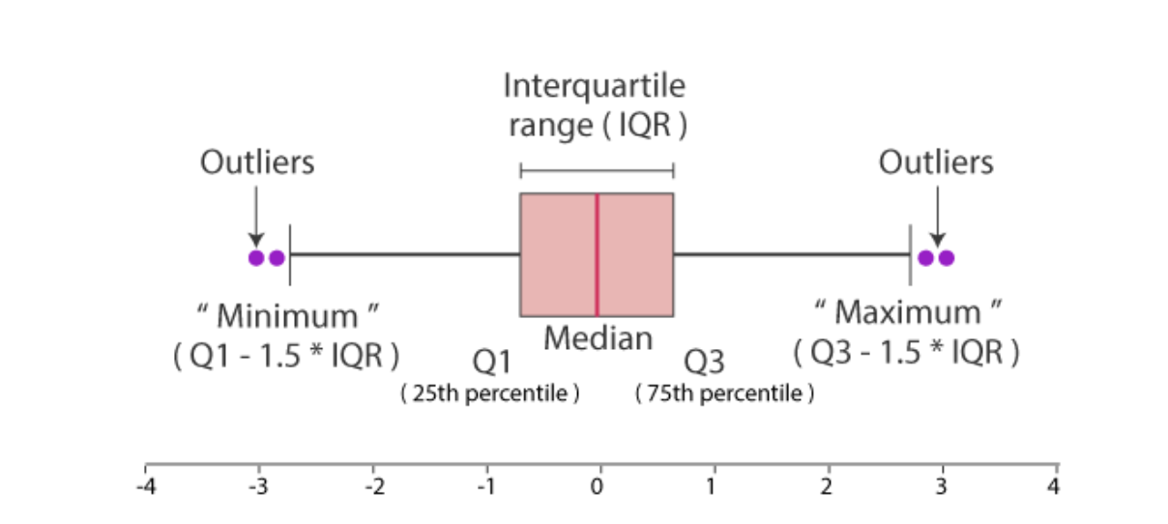

**[17]**

**Conclusion**

Overall, researchers and other people taking the survey can learn a lot about user behavior and preferences like using these fundamental quantitative analytic approaches and visualizations, which can help them enhance the recommendation engine and enhance user experience.

**References**

1. National Academic Press (2018) *Digital Technology.*

   Available at: <https://nap.nationalacademies.org/read/24783/chapter/10>

   (Accessed: 4 May 2023).
2. Gayane Tamrazyan (2020) *Voice Search And Virtual Assistants: Pains Vs Gains For Ecommerce*Available at: <https://simtechdev.com/blog/voice-search-and-virtual-assistants-pains-vs-gains-for-ecommerce/>

   (Accessed: 5 May 2023).
3. Steemit (2019) *The Scary Downsides of Amazon Go****.***

   Available at: <https://steemit.com/technology/@sharebear/the-scary-downsides-of-amazon-go>

    (Accessed: 4 May 2023).
4. Sean Ogino (2021) *Potential Problems for Amazon Go, and Other Sellers Skipping Lines****.***

   Available at: <https://www.annexcloud.com/blog/potential-problems-amazon-go-sellers-skipping-lines/>

   (Accessed: 4 May 2023).
5. Michigan Technological University (2015) [*Human-Computer Interactions & Usability*](http://cs4760.csl.mtu.edu/2017/)

   Available at: <http://cs4760.csl.mtu.edu/2017/lectures/interaction-styles-and-mobile-interactions/>

    (Accessed: 12 May 2023).
6. Ian Sommerville (2009)  *Interaction Design* Available at <https://ifs.host.cs.st-andrews.ac.uk/Books/SE9/WebChapters/PDF/Ch_29%20Interaction_design.pdf>

    (Accessed: 12 May 2023).
7. [Fred Churchville](https://www.techtarget.com/contributor/Fred-Churchville) (2019) *user interface (UI)*

   Available at <https://www.techtarget.com/searchapparchitecture/definition/user-interface-UI>

    (Accessed: 12 May 2023).
8. [RAHUL](https://technotrice.com/author/rahul/) (2014) *What Is Spiral Model? – It’s Advantages & Disadvantages*

   Available at <https://technotrice.com/what-is-spiral-model-software-engineering/>

    (Accessed: 5 May 2023).
9. SitesBay (2014) *What is Spiral Model*

   Available at <https://www.sitesbay.com/software-engineering/se-spiral-model>

    (Accessed: 4 May 2023).
10. [Aishwarya Bhatia](https://medium.com/@aishwaryabhatia?source=post_page-----90ea20cabc76--------------------------------) (2022) *How to effectively build wireframes and create low-fidelity prototypes for your project?*Available at <https://uxplanet.org/what-did-i-learn-from-google-ux-design-specialization-3-7-90ea20cabc76>

     (Accessed: 4 May 2023).
11. UiConnect (2016) *Quancious*

    Available at <https://www.uiconnect.in/case-studies/agency-collaboration-quancious/>

     (Accessed: 4 May 2023).
12. User Interviews (2013) *Surveys*

    Available at <https://www.userinterviews.com/ux-research-field-guide-chapter/surveys#:~:text=In%20UX%20research%2C%20surveys%20are,to%20automate%20ongoing%20data%20collection>.

     (Accessed: 4 May 2023).
13. Heale, R and Twycross, AM (2017) *5 What is a case study?*

    Available at <https://openresearch.lsbu.ac.uk/item/86w69>

     (Accessed: 4 May 2023).
14. Hot Jar (2013) *5 qualitative data analysis methods*

    Available at <https://www.hotjar.com/qualitative-data-analysis/methods/>

     (Accessed: 4 May 2023).
15. James Chen(2022) *How a Histogram Works to Display Data*

    Available at <https://www.investopedia.com/terms/h/histogram.asp#:~:text=A%20histogram%20is%20a%20bar,visualize%20patterns%20of%20data%20distributions>.

     (Accessed: 4 May 2023).
16. [Mike](https://www.techtarget.com/contributor/Fred-Churchville) Yi (2021) *A Complete Guide to Scatter Plots*

    Available at <https://chartio.com/learn/charts/what-is-a-scatter-plot/>

     (Accessed: 4 May 2023).
17. Byju‘s (2023) *Box Plot*

    Available at <https://byjus.com/maths/box-plot/>

     (Accessed: 4 May 2023).